Bahria University

Karachi Campus

**COURSE: Data Communication and Networking**

COURSE CODE: **CEN-222**

**PROJECT REPORT**

**SUBMITTED BY:**

Name of group members and registration number:

1. Muhammad Arbab Anjum (57226)
2. Aqib Mehmood (57231)
3. Syed Ali Abbas (57285)

**SUBMITTED TO:**

Engr. Mahawish Fatima/ Engr. Fareeha Dilawar

**SIGNED REMARKS: SCORE:**

Table of Contents

BACKGROUND: 3

INTRODUCTION: 4

PROJECT PARADIGM 5

MECHANISM AND WORKING: 6

FUNCTIONALITIES: 12

FUTURE WORK: 17

CONCLUSION: 18

REFERENCES: 19

# BACKGROUND:

## Describe the history of old procedures, processes followed under this project.

“Networks in which computers are assigned to LAN segments by software rather than by hardware.”

These are often faster, while providing greater opportunities to manage the flow of traffic on the LAN and Backbone Network (BN) in comparison to traditional LAN and routed BN architectures. Allows creation of two or more virtual switches from a single switch. Assigning individual ports to a specific virtual switch. First products allowed switching of multiple segments on a single switch, as well as offering a monetary advantage over switched Ethernet ports which cost $700 or more at the time. Although it was possible to use [IP routing](https://en.wikipedia.org/wiki/IP_routing) to connect multiple Ethernet networks together, it was expensive and relatively slow. Sincoskie started looking for alternatives that required less processing per packet. In the process, he independently reinvented [transparent bridging,](https://en.wikipedia.org/wiki/Transparent_bridging) the technique used in modern [Ethernet switches.](https://en.wikipedia.org/wiki/Ethernet_switch) However, using switches to connect multiple Ethernet networks in a fault-tolerant fashion requires redundant paths through that network, which in turn requires a [spanning tree](https://en.wikipedia.org/wiki/Spanning_tree) configuration. This ensures that there is only one *active* path from any source node to any destination on the network. This causes centrally located switches to become bottlenecks, limiting scalability as more networks are interconnected.

# INTRODUCTION:

## Introduce your project what is it about

It is a sales management system with security. Where we have multiple departments located at 4 Cities. Each department is Operatble at different VLANS. The Local Area Network (LAN) is widely used because a large number of applications imply some user in the same broadcast domain. There is kind of LAN named virtual LAN (VLAN), in this sort of network a group of hosts with a set of common requirements provides communication. It is important to emphasize that the group of hosts should be in the same broadcast domain, despite the same place

Other networks like Metropolitan Area Network (MAN) or Wide Area Network (WAN) are not compatible with virtual technologies, because the elements of the VLAN normally share routing and switching.

The project is to understand the advantages of using VLAN in a network, how broadcasting is controlled. Understand the configuration which is required to setup a VLAN based network using Cisco routers and switches.

The main goal of this work is to increase the security level of the LAN, in order to reduce the access to undesirable sites and to avoid the presence of hackers in the internet.

**Key-Words:** LAN, VLAN, security, Internet, TCP, switching, RIPv2, Router, Switch

# PROJECT PARADIGM

## Explain your project’s complete knowledge (pattern). Answer to “WHY”.

**VLAN:**

A virtual LAN (VLAN) abstracts the idea of the LAN; A VLAN might comprise a subset of the ports on a single switch or subsets of ports on multiple switches. By default, systems on one VLAN don't see the traffic associated with systems on other VLANs on the same network.

**WHY?**

VLANs allow network administrators to partition their networks to match the functional and security requirements of their systems without having to run new cables or make major changes in their current network infrastructure. IEEE 802.1Q is the standard defining VLANs; the VLAN identifier or tag consists of 12 bits in the Ethernet frame, creating an inherent limit of 4,096 VLANs on a LAN.

* Uses physical address to form VLANs.
* A software is used to instruct the switch as to which incoming addresses are assigned to which VLAN segment.
* Easier to manage than Port-based.

**Use Case:**

We are using Enterprises Network Model to show the use case of Vlan and how Real Scenario works when Different Branches of Enterprises are located in Different Cities.

# MECHANISM AND WORKING:

## “Paste here the code” and outputs. Explain it step by step. Answer to “HOW”.

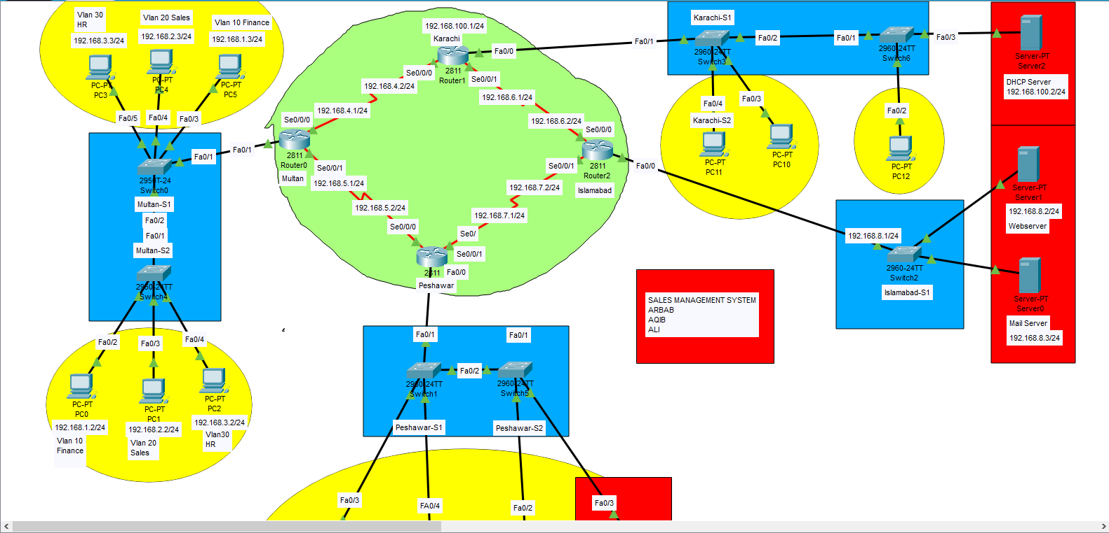

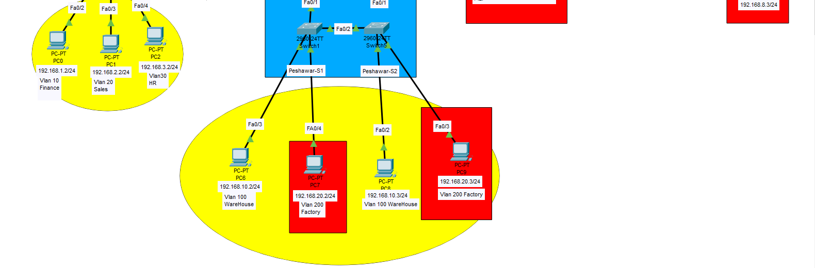

**This is an organisation where we have offices located in four metropolitan cities-:**

Network consists of a Four locations,

1. Multan
2. Peshawar
3. Karachi
4. Islamabad

1. The Multan location has 3 VLANS. They are VLAN 10(Sales), VLAN 20(Finance) and VLAN 30(HR).The Multan router is configured with proper banner and enable secret as 'Multan@cisco' and VTY password as

'cisco'.

1. The Peshawar location has 2 VLANs. They are VLAN 100(Warehouse) and VLAN 200(Factory). Peshawar router is configured with proper banner and enable secret as 'Peshawar@cisco', VTY password as 'cisco'.
2. The Islamabad location contains the Webserver(192.168.8.2/24) and the Mail server(192.168.8.3/24).Islamabad router is configured with proper banner and enable secret as 'Islamabad@cisco' and VTY password as 'cisco'.
3. The Karachi location has only the office LAN in 192.168.100.0/24 subnet and each computer is getting IP address from the DHCP Server 192.168.1002/24. Karachi router is configured with a proper banner. The enable secret is 'Karachi@cisco and VTY password is 'cisco'.
4. Multan, Peshawar and Karachi location is connected via Point-to-Point leased line.

1. Users of all regions except the Factory VLAN will have access to the Webserver and Mail server.
2. Inter VLAN routing has been performed and RIPv2 is used as the routing protocol.

**Vlan IP:**

VLAN 10 (Finance) -- 192.168.1.0/24 VLAN 20(Sales) -- 192.168.2.0/24

VLAN 30 (HR) -- 192.168.3.0/24 VLAN 100 (Warehouse) - 192.168.10.0/24 VLAN 200 (Factory) -- 192.168.20.0/24

**LAN IP:**

Islamabad LAN - 192.168.8.0/24

Karachi LAN - 192.168.100.0/24

**WAN IP:**

Multan to Peshawar WAN - 192.168.5.0/24

Multan to Karachi WAN - 192.168.4.0/24

Islamabad to Karachi WAN- 192.168.6.0/24

Islamabad to Peshawar WAN --192.168.7.0/24

**Multan Configuration:**

Multan#show running-config

Building configuration...

Current configuration : 1395 bytes

!

version 12.4

no service timestamps log datetime msec

no service timestamps debug datetime msec

service password-encryption

hostname Multan

enable secret 5 $1$mERr$z/f2vKz1eL.ar8.vkgXx3/

ip cef

no ipv6 cef

username Karachi password 7 08701E1D5D4C

spanning-tree mode pvst

interface FastEthernet0/0

no ip address

duplex auto

speed auto

interface FastEthernet0/1

no ip address

duplex auto

speed auto

interface FastEthernet0/1.1

encapsulation dot1Q 10

ip address 192.168.1.1 255.255.255.0

!

interface FastEthernet0/1.2

encapsulation dot1Q 20

ip address 192.168.2.1 255.255.255.0

!

interface FastEthernet0/1.3

encapsulation dot1Q 30

ip address 192.168.3.1 255.255.255.0

!

interface Serial0/0/0

ip address 192.168.4.1 255.255.255.0

clock rate 2000000

!

interface Serial0/0/1

ip address 192.168.5.1 255.255.255.0

clock rate 2000000

!

interface Serial0/1/0

no ip address

clock rate 2000000

shutdown

!

interface Serial0/1/1

no ip address

clock rate 2000000

shutdown

!

interface Vlan1

no ip address

shutdown

!

router rip

version 2

network 192.168.1.0

network 192.168.2.0

network 192.168.3.0

network 192.168.4.0

network 192.168.5.0

!

ip classless

!

ip flow-export version 9

banner motd ^C

This is the Multan Router^C

line con 0

!

line aux 0

!

line vty 0 4

password 7 0822455D0A16

login

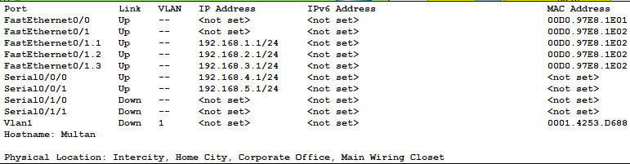

**Peshawar Configuration:**

Peshawar#show running-config

Building configuration...

Current configuration : 1249 bytes

!

version 12.4

no service timestamps log datetime msec

no service timestamps debug datetime msec

service password-encryption

!

hostname Peshawar

!

!

!

enable secret 5 $1$mERr$.rfN9UOfAbAe8.Tilqn0Q.

!

ip cef

no ipv6 cef

spanning-tree mode pvst

!

!

interface FastEthernet0/0

no ip address

duplex auto

speed auto

!

interface FastEthernet0/0.1

encapsulation dot1Q 100

ip address 192.168.10.1 255.255.255.0

!

interface FastEthernet0/0.2

encapsulation dot1Q 200

ip address 192.168.20.1 255.255.255.0

!

interface FastEthernet0/1

no ip address

duplex auto

speed auto

shutdown

!

interface Serial0/0/0

ip address 192.168.5.2 255.255.255.0

!

interface Serial0/0/1

ip address 192.168.7.1 255.255.255.0

clock rate 2000000

!

interface Serial0/1/0

no ip address

clock rate 2000000

shutdown

!

interface Serial0/1/1

no ip address

clock rate 2000000

shutdown

!

interface Vlan1

no ip address

shutdown

!

router rip

version 2

network 192.168.5.0

network 192.168.7.0

network 192.168.10.0

network 192.168.20.0

!

ip classless

!

ip flow-export version 9

!

!

!

no cdp run

!

banner motd ^C

This is the Peshawar router^C

line con 0

!

line aux 0

!

line vty 0 4

password 7 0822455D0A16

login

end

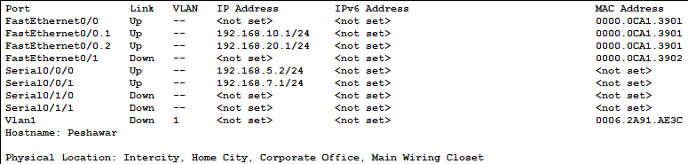

**Karachi Configuration:**

Karachi#show running-config

Building configuration...

Current configuration : 1147 bytes

!

version 12.4

no service timestamps log datetime msec

no service timestamps debug datetime msec

service password-encryption

!

hostname Karachi

!

!

!

enable secret 5 $1$mERr$B7l.NIum/Onfb6huqxne9.

!

!

ip cef

no ipv6 cef

!

!

username Islamabad password 7 08701E1D5D4C

username Multan password 7 08701E1D5D4C

!

!

spanning-tree mode pvst

!

!

interface FastEthernet0/0

ip address 192.168.100.1 255.255.255.0

duplex auto

speed auto

!

interface FastEthernet0/1

no ip address

duplex auto

speed auto

shutdown

!

interface Serial0/0/0

ip address 192.168.4.2 255.255.255.0

!

interface Serial0/0/1

ip address 192.168.6.1 255.255.255.0

clock rate 64000

!

interface Serial0/1/0

no ip address

clock rate 2000000

shutdown

!

interface Serial0/1/1

no ip address

clock rate 2000000

shutdown

!

interface Vlan1

no ip address

shutdown

!

router rip

version 2

network 192.168.4.0

network 192.168.6.0

network 192.168.100.0

!

ip classless

!

ip flow-export version 9

!

!

!

no cdp run

!

banner motd ^C

This is the Karachi Router^C

!

line con 0

!

line aux 0

!

line vty 0 4

password 7 0822455D0A16

login

!

!

!

end

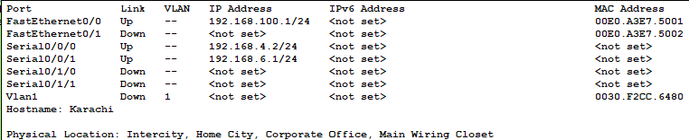

**Islamabad Configuration:**

Islamabad#show running-config

Building configuration...

Current configuration : 1166 bytes

!

version 12.4

no service timestamps log datetime msec

no service timestamps debug datetime msec

no service password-encryption

!

hostname Islamabad

!

!

!

enable secret 5 $1$mERr$5B4cN0v3.V97MSAzkJqao.

!

!

ip cef

no ipv6 cef

!

username Karachi password 0 12345

!

spanning-tree mode pvst

!

!

interface FastEthernet0/0

ip address 192.168.8.1 255.255.255.0

ip access-group 50 out

duplex auto

speed auto

!

interface FastEthernet0/1

no ip address

duplex auto

speed auto

shutdown

!

interface Serial0/0/0

ip address 192.168.6.2 255.255.255.0

!

interface Serial0/0/1

ip address 192.168.7.2 255.255.255.0

!

interface Serial0/1/0

no ip address

clock rate 2000000

shutdown

!

interface Serial0/1/1

no ip address

clock rate 2000000

shutdown

!

interface Vlan1

no ip address

shutdown

!

router rip

version 2

network 192.168.6.0

network 192.168.7.0

network 192.168.8.0

!

ip classless

!

ip flow-export version 9

!

!

access-list 50 deny 192.168.20.0 0.0.0.255

access-list 50 permit any

!

no cdp run

!

banner motd ^C

This is the Islamabad router^C

!

!

line con 0

!

line aux 0

!

line vty 0 4

password cisco

login

!

end

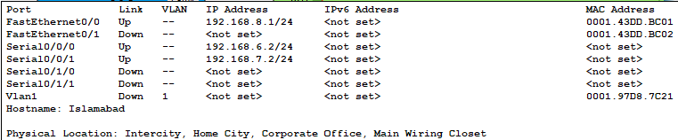

# FUNCTIONALITIES:

## Explain the deliverables of the project considering DCN concepts and theories.

Concepts Used:

* TCP
* LAN
* WAN
* VLAN
* RIPv2
* Router
* Switch
* Security
* Internet
* Switching

We are using Enterprises Network Model to show the use case of VLAN and how Real Scenario works when Different Branches of Enterprises are located in Different Cities.

We have different Departments, Factories, Ware houses and servers.

Department’s data will be stored at servers which means departments and ware houses can access servers while factory will not be able to access the servers.

# FUTURE WORK:

## Explain what is coming up next in future in Upgradation to this.

So the Upgradation to the new versions will be:

* Performance
* Simplified Administration
* Cost and Time Reduction
* Broadcast control
* Virtual Work Groups
* Security
* Physical Layer Transparency

In networks where traffic consists of a high percentage of broadcasts and multicasts, VLAN's can reduce the need to send such traffic to unnecessary destinations. 70% network costs are a result of adds, moves, and changes of users in the network. Every time a user is moved in a LAN, new station addressing, and reconfiguration of hubs and routers becomes necessary. VLANs can reduce the migration cost of stations going from one group to another. Physical reconfiguration takes time and is costly. Instead of physically moving one station to another segment or even to another switch, it is much easier and quicker to move it by using software. A layer 3 device (typically a Router) is used to segment a broadcast domain. VLANs provide an extra measure of security. People belonging to the same group can send broadcast messages with the guaranteed assurance that users in other groups will not receive these messages.

# CONCLUSION:

## End note or summary to the above explained project description.

In this Project, the design and implementation of a VLAN is carried out. The main goals is: to optimize the network resources, to give security and to provide a real-time users monitoring, in order to avoid time wasting. As a result of this work, the solution implemented can be changed according to current organization requirements. This is especially useful, because the workstations can be easily relocated if necessary.

# 

# REFERENCES:

## Useful links involved in making the projects. List all of them here.

1. Andrew S. Tanenbaum, Computer Networks, Prentice Hall, Fourth Edition, 2002.
2. <https://en.wikipedia.org/wiki/Virtual_LAN>
3. http://searchnetworking.techtarget.com/tutorial/VLAN-guide-for-networking-professionals